Relational Database Service
TASK 1: Create MariaDB Database on EC2
Step 1: Launch EC2
Login to AWS Console
Go to
EC2 → Launch Instance
Choose
- Name: mariadb-server
- AMI: Amazon Linux 2023
- Instance: t2.micro
- Key pair: Existing
- Security Group
Allow
Type | Port
SSH | 22
MySQL/Aurora | 3306
Launch instance.
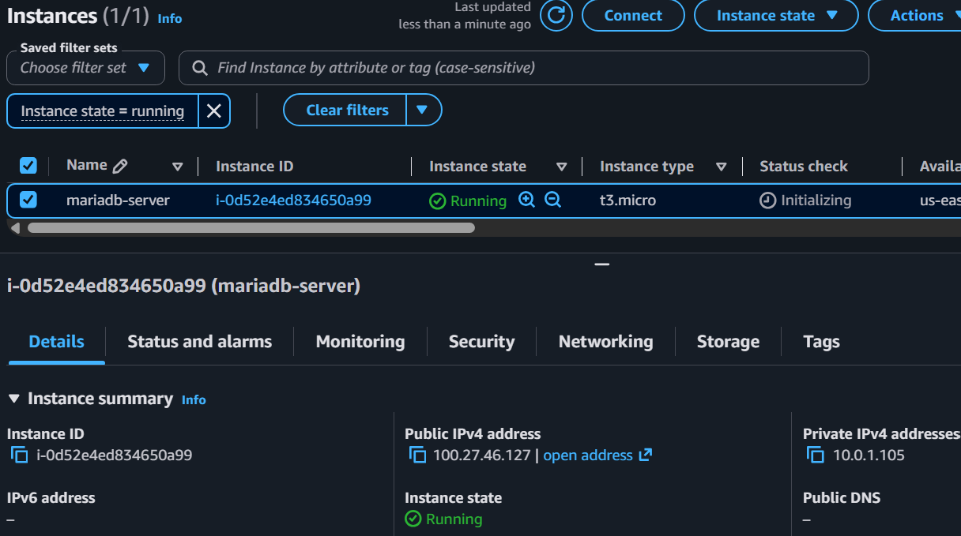
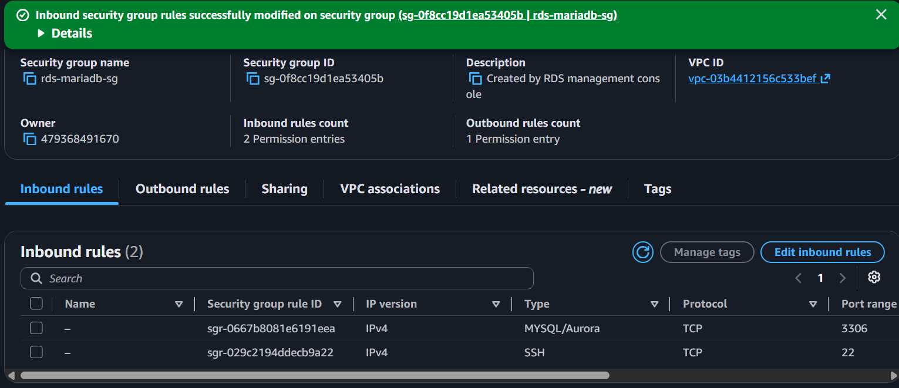

Step 2: Connect
ssh -i key.pem ec2-user@Public-IP
Update server
sudo dnf update -y
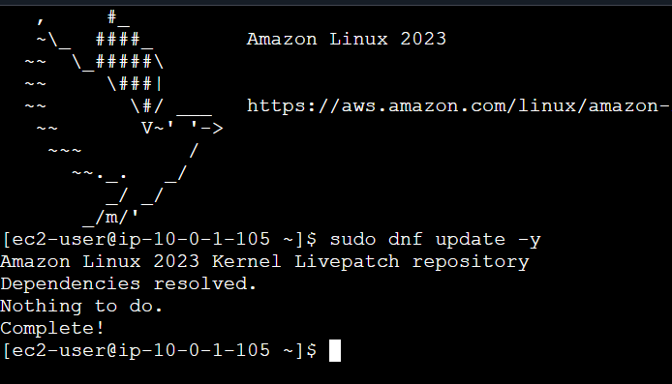

Step 3: Install MariaDB
sudo dnf install mariadb105-server -y
If package not found
sudo dnf install mariadb-server -y
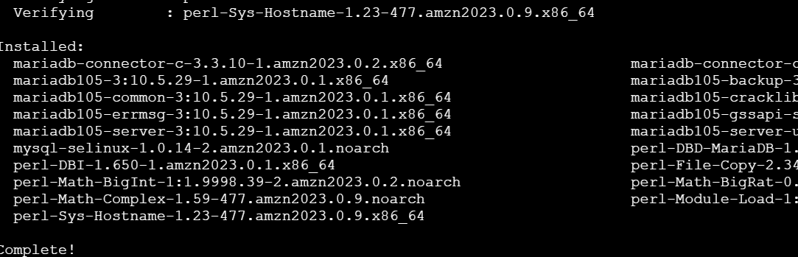
Start service
sudo systemctl enable mariadb
sudo systemctl start mariadb
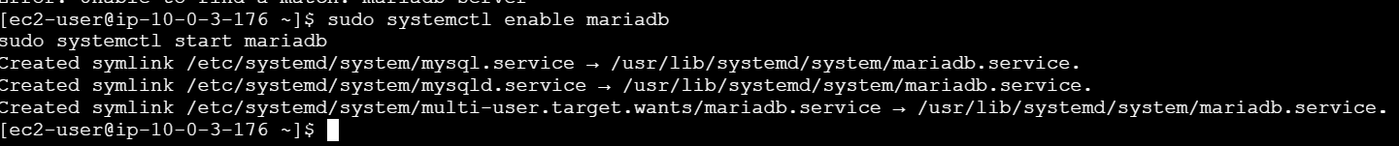
Verify
sudo systemctl status mariadb
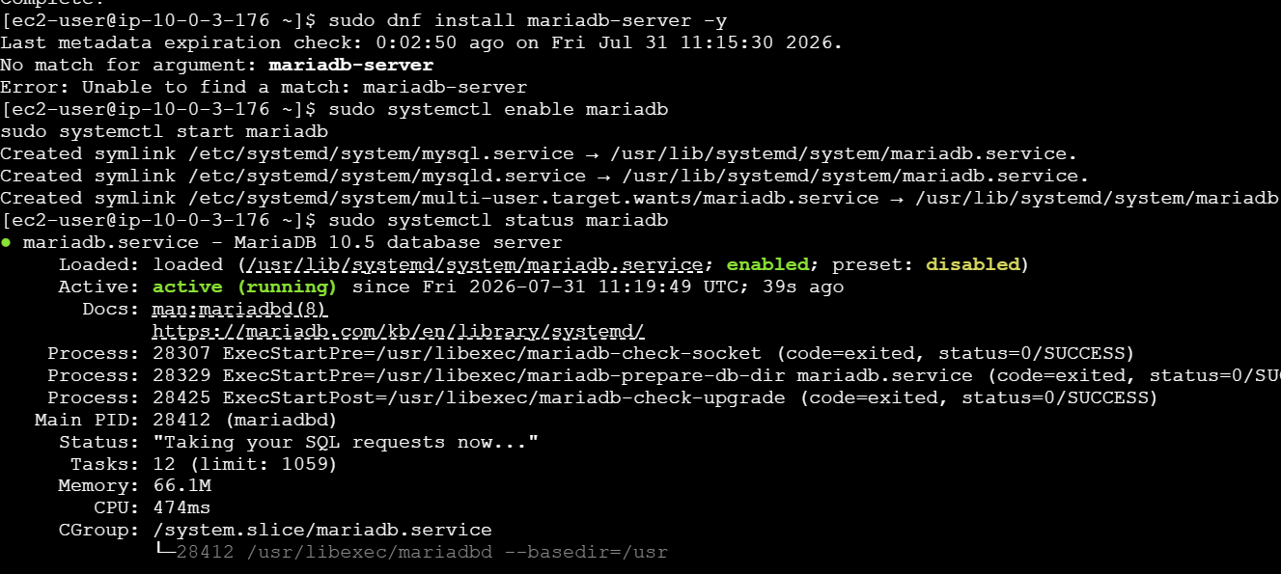

Step 4: Secure Installation
sudo mysql_secure_installation
Recommended answers
Set root password -> Yes

Remove anonymous users -> Yes

Disallow remote login -> Yes

Remove test database -> Yes

Reload privilege tables -> Yes

Step 5: Login
sudo mysql -u root -p
Check version
SELECT VERSION();
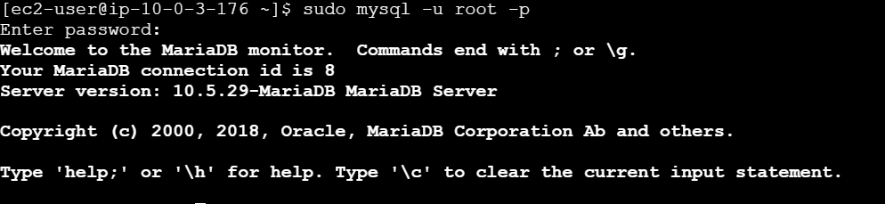

TASK 2: Insert Dummy Data
Create database
CREATE DATABASE company;
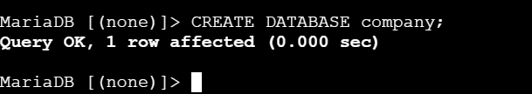
Use database
USE company;
Create table
CREATE TABLE employees
(
id INT PRIMARY KEY AUTO_INCREMENT,
name VARCHAR(50),
department VARCHAR(50),
salary INT
);
Insert data
INSERT INTO employees(name,department,salary)
VALUES
('John','IT',50000),
('Alice','HR',45000),
('David','Finance',60000),
('Mike','Admin',42000),
('Sara','DevOps',70000);
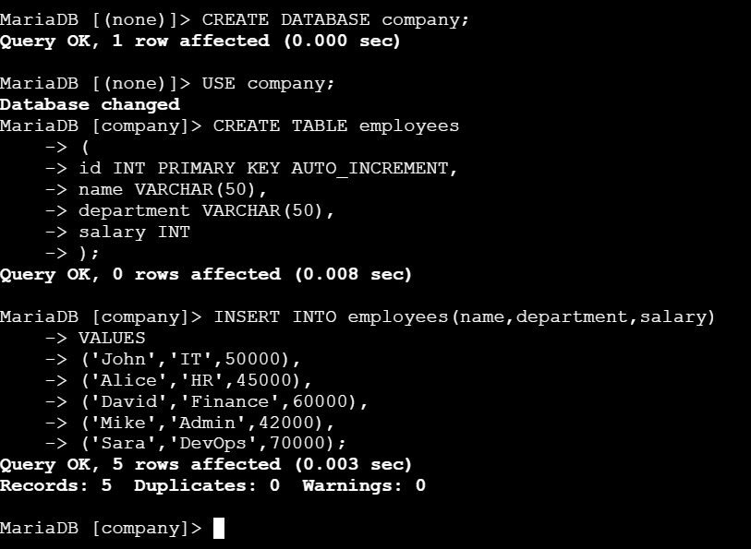
View
SELECT * FROM employees;
Exit
exit;
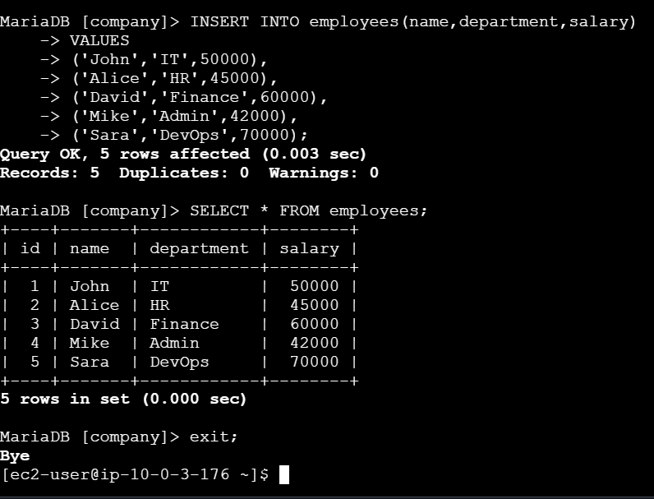

TASK 3: Backup Database on EC2
Create backup folder
mkdir backups
Take backup
sudo mysqldump -u root company > backups/company_backup.sql
Verify
ls -lh backups/
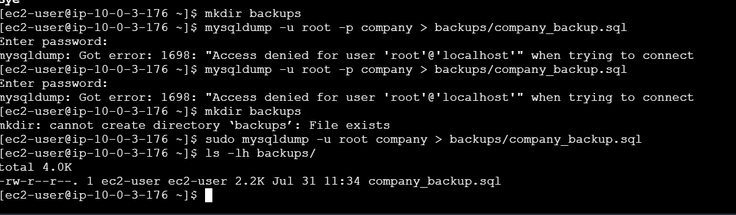
You should see:
company_backup.sql
Check the first few lines:
head backups/company_backup.sql
If you see lines beginning with:
-- MariaDB dump
then the backup was created successfully.
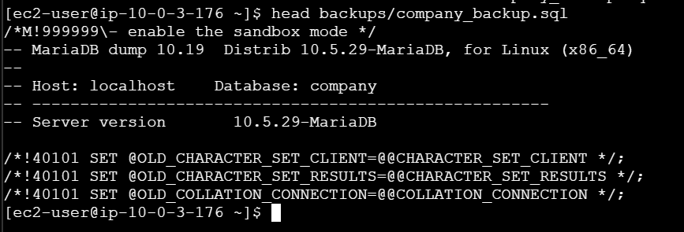

Task 4: Launch MariaDB RDS (us-east-1)
Step 1: Open RDS
AWS Console → RDS →Aurora and RDS → Create database → Full Configuration

Step 2: Choose Database Creation Method
- Database creation method: Standard Create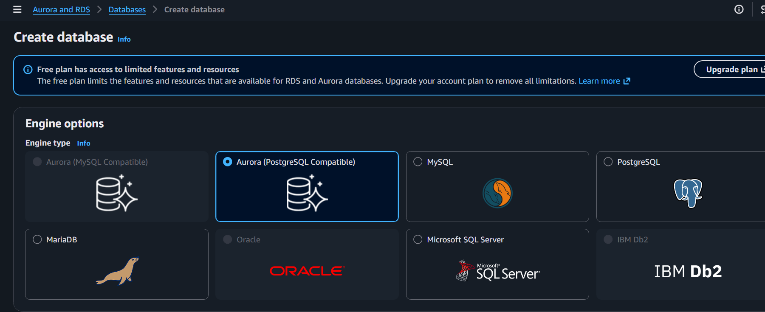

Step 3: Engine Options
- Engine type: MariaDB
- Engine version: Latest available (or default)

Step 4: Templates
Choose:
- Free tier (if available)
If Free Tier isn't shown, select Dev/Test and use the smallest instance class.
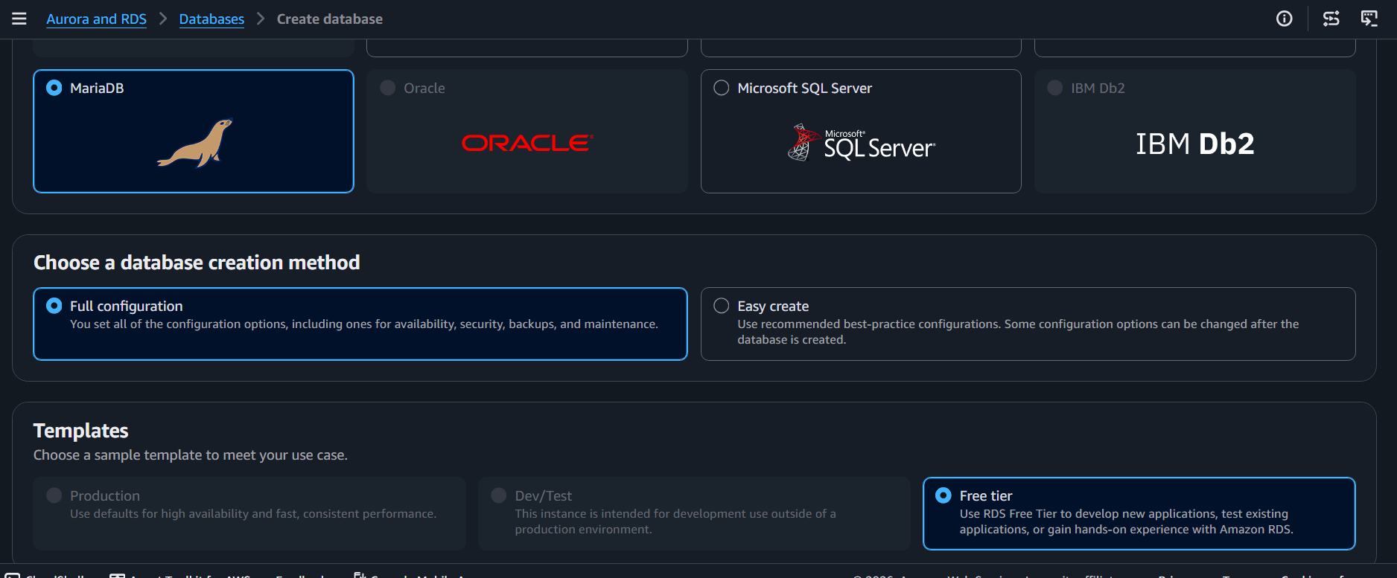

Step 5: Settings
DB instance identifier
mariadb-rds
Master username
Admin
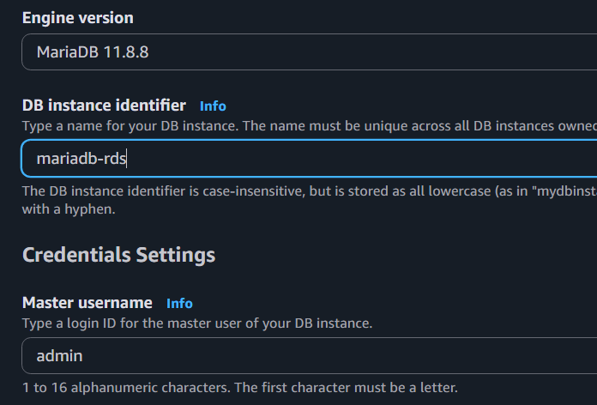
Master password
Choose a password such as:
Password@123
(Use your own secure password and remember it.)

Step 6: Instance Configuration
DB instance class:
db.t4.micro
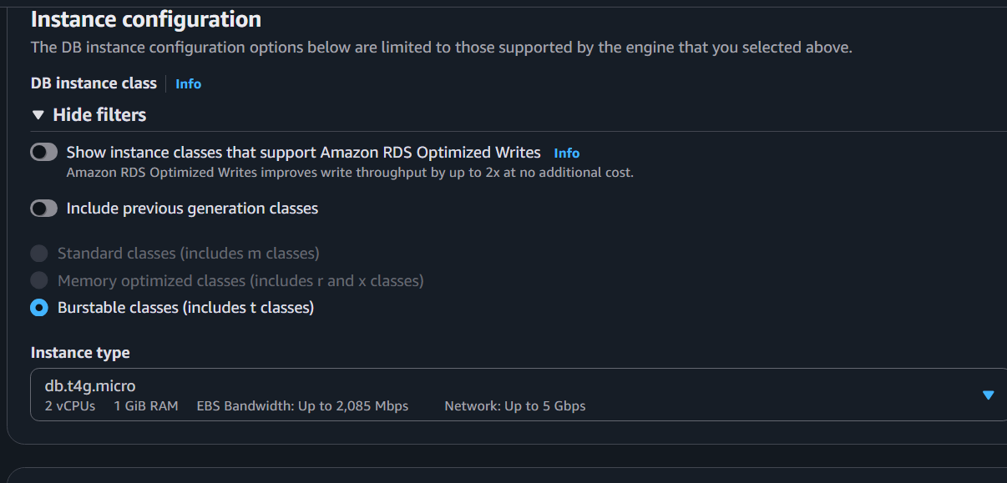

Step 7: Storage
- Storage type: General Purpose SSD (gp3) (default)
- Allocated storage: 20 GB
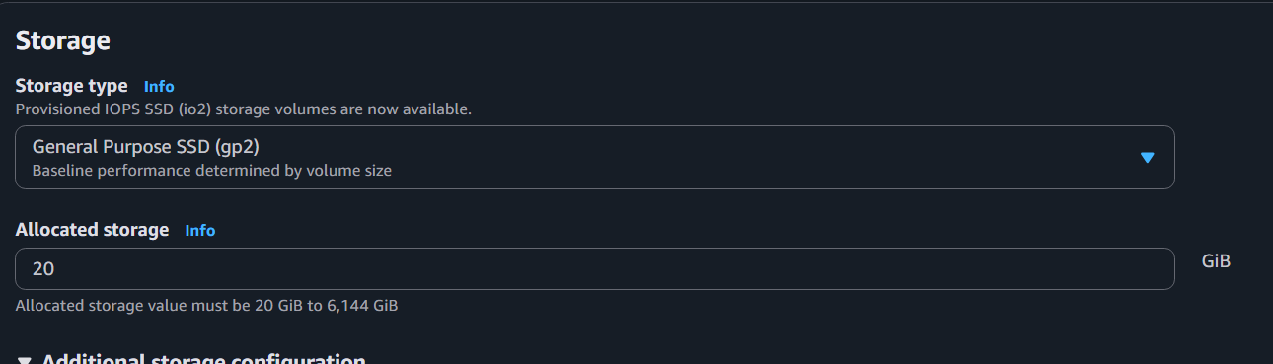

Step 8: Connectivity
Choose:
- VPC: Same VPC where your EC2 instance is running.
- Public access: Yes (for this lab)
- VPC security group: Create new or select an existing one.
Instead of default, I recommend:
- Create new VPC Security Group
For example:
rds-mariadb-sg
We'll add an inbound rule for port 3306 after the database is created.
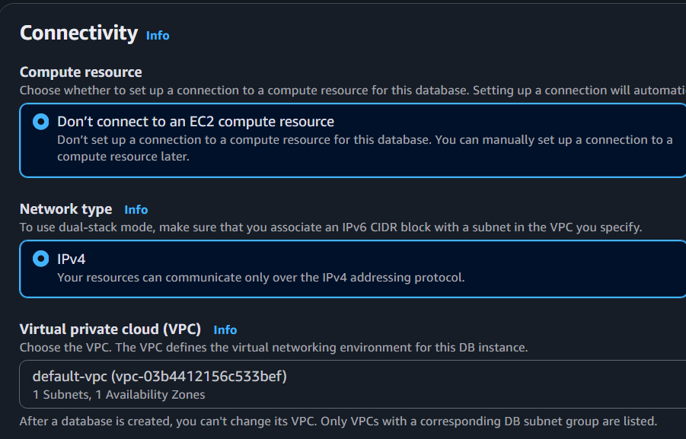
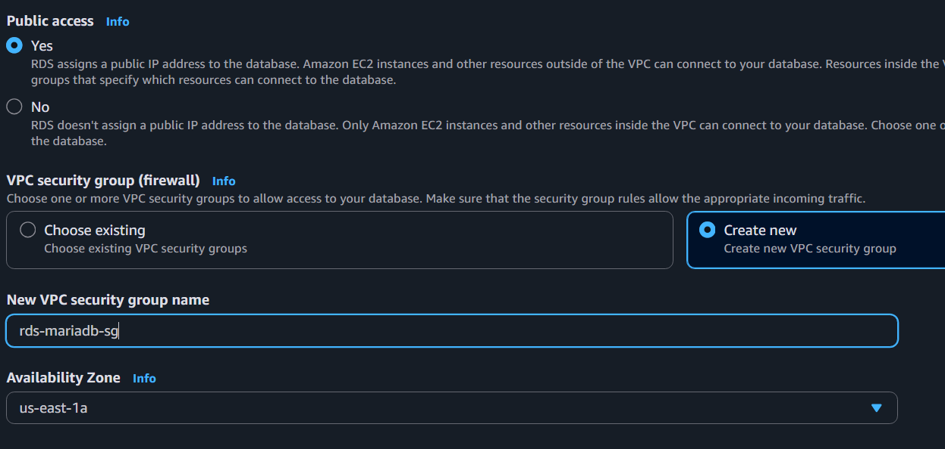

Step 9: Configure Security Group
The RDS security group must allow MySQL/Aurora (TCP 3306).
The most secure option is:
- Source: Your EC2 instance's security group.
For a simple lab, you can temporarily allow your IP or the EC2 security group.
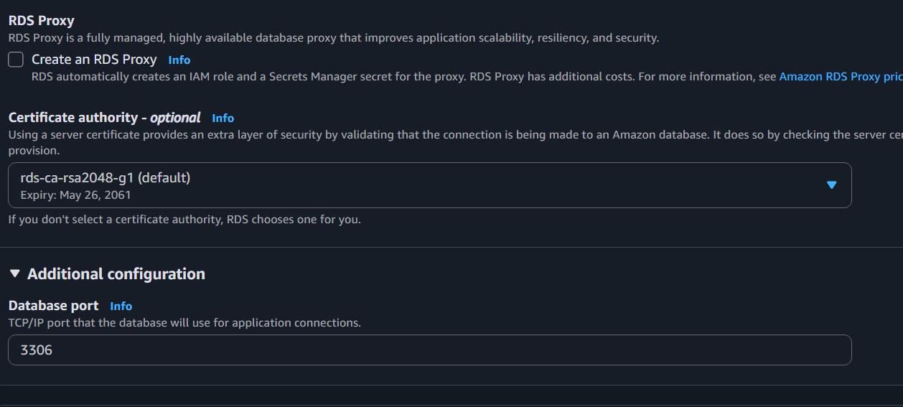

Step 10: Additional Configuration
Initial database name
company
Leave the remaining settings at their defaults.
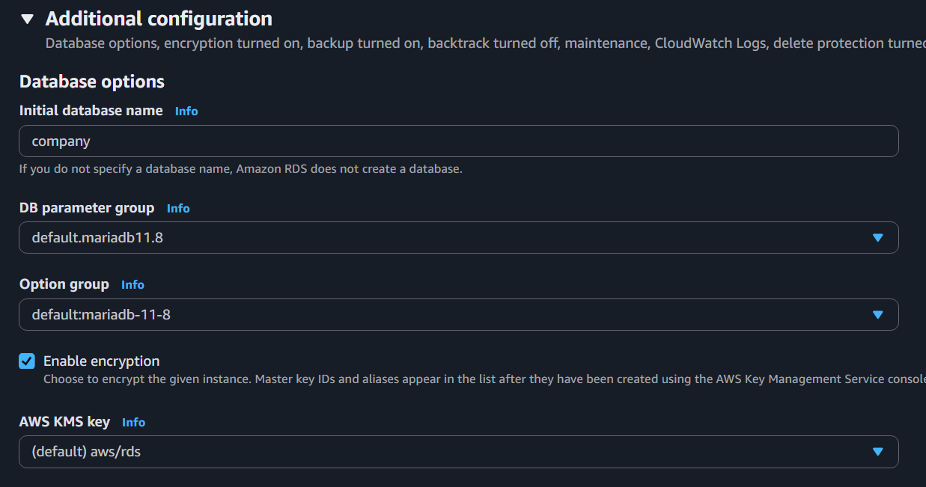

Step 11: Create Database
Click Create database.
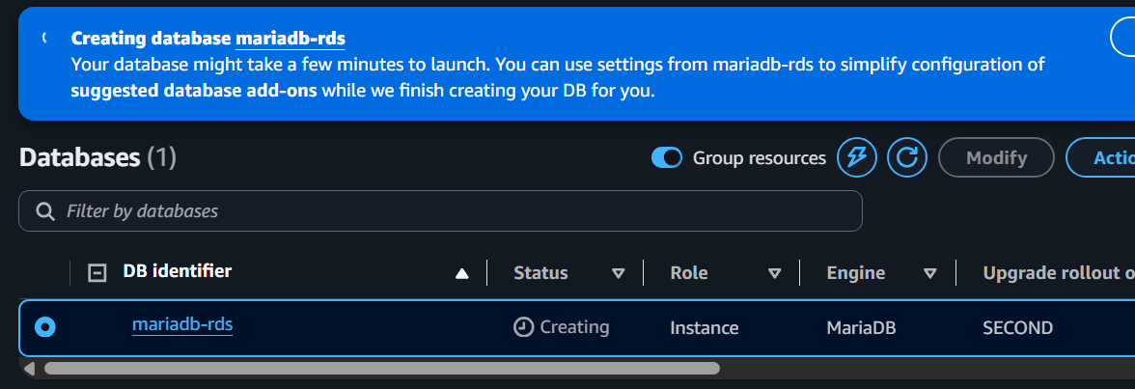
Wait until the status changes to:
Available
This typically takes 5–10 minutes.
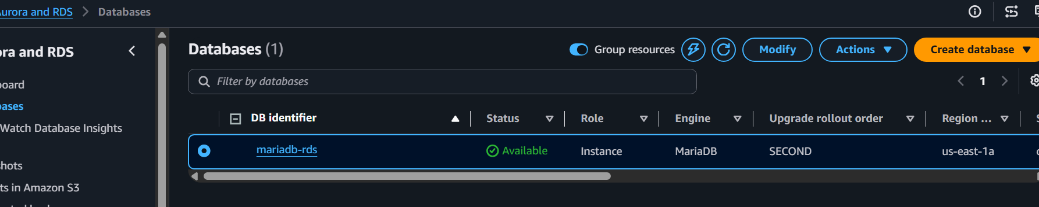

After It Is Available
Copy the Endpoint from the RDS details page.
It will look similar to:
mariadb-rds.xxxxxxxxx.us-east-1.rds.amazonaws.com
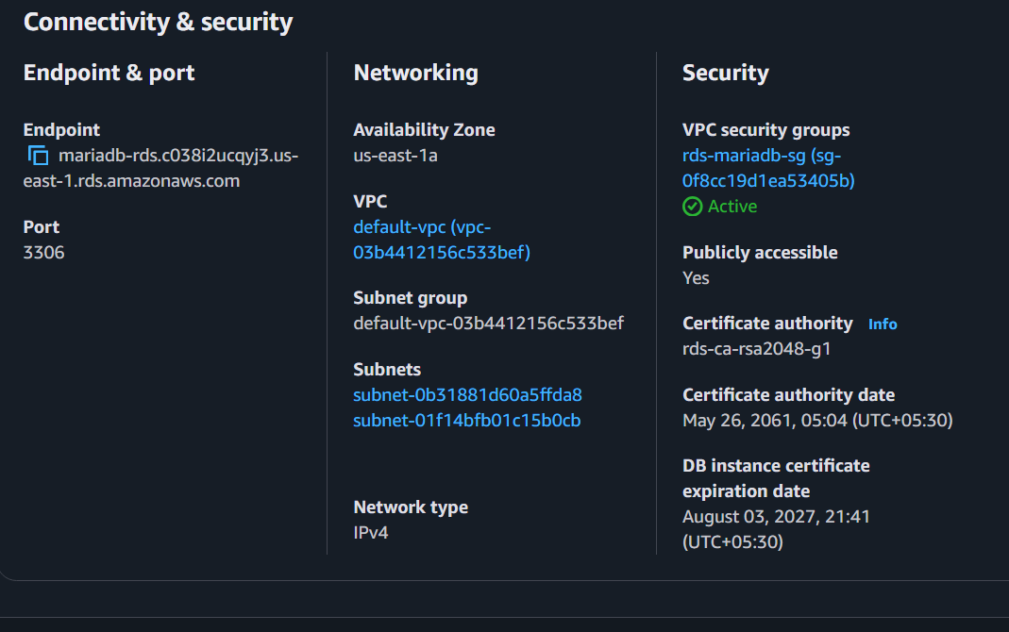
mariadb-rds.c038i2ucqyj3.us-east-1.rds.amazonaws.com

TASK 5: Migrate Database EC2 → MariaDB RDS
Install client
sudo dnf install mariadb -y
Test connectivity
mysql -h RDS-ENDPOINT \
-u admin \
-p
Create DB
CREATE DATABASE company;
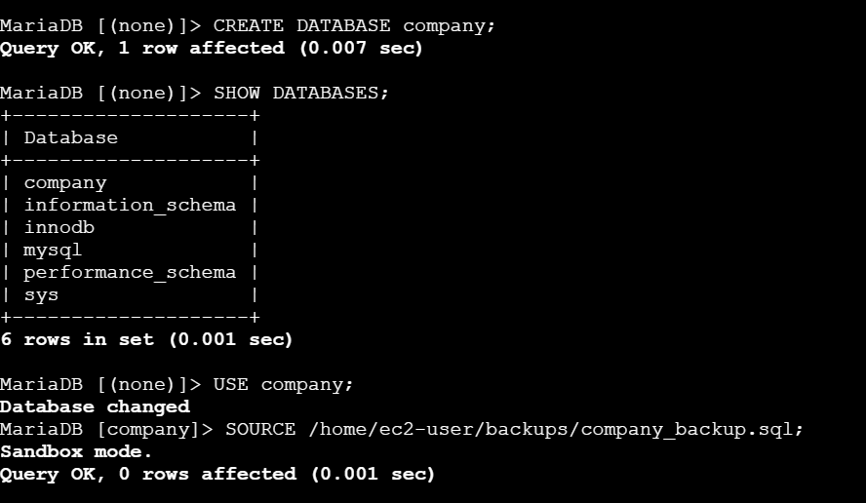
Exit.
Import backup
mysql -h RDS-ENDPOINT \
-u admin \
-p company < backups/company_backup.sql
Login
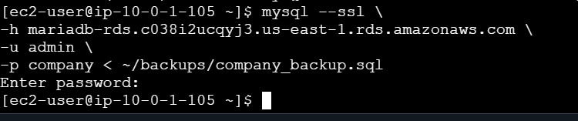
mysql --ssl \
-h mariadb-rds.c038i2ucqyj3.us-east-1.rds.amazonaws.com \
-u admin \
-p company < ~/backups/company_backup.sql

mysql -h RDS-ENDPOINT -u admin -p
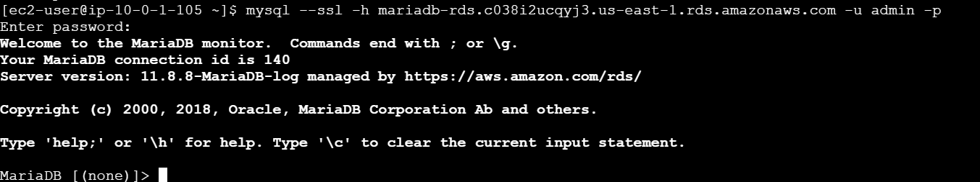
mysql --ssl \
-h mariadb-rds.c038i2ucqyj3.us-east-1.rds.amazonaws.com \
-u admin \
-p
Verify
USE company;
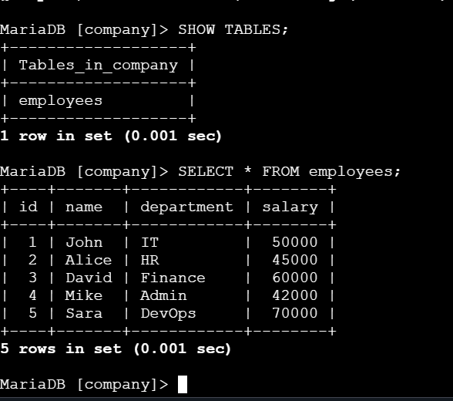
SELECT * FROM employees;
Migration completed.

TASK 6: Install MySQL on EC2
. Install MySQL DB on EC2.
Prerequisites
EC2 instance (Amazon Linux 2023)
SSH access
sudo privileges
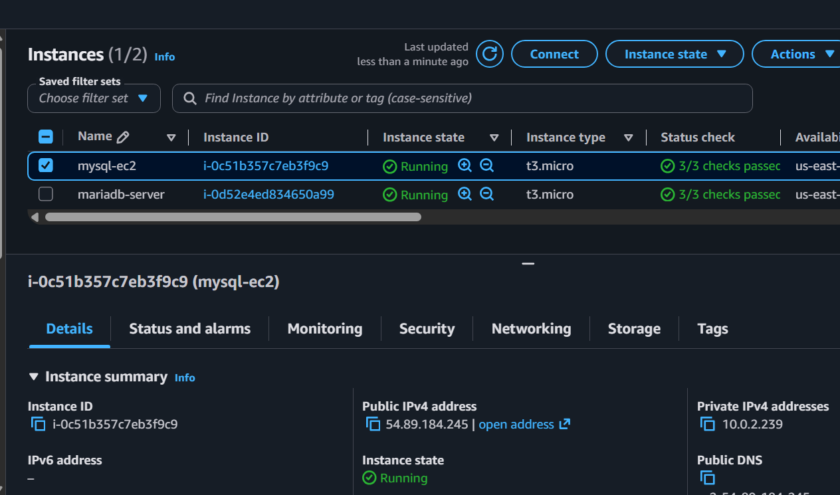
Step 1: Install MariaDB Server
Run:
sudo dnf install mariadb118 mariadb118-server -y
Wait for the installation to complete.
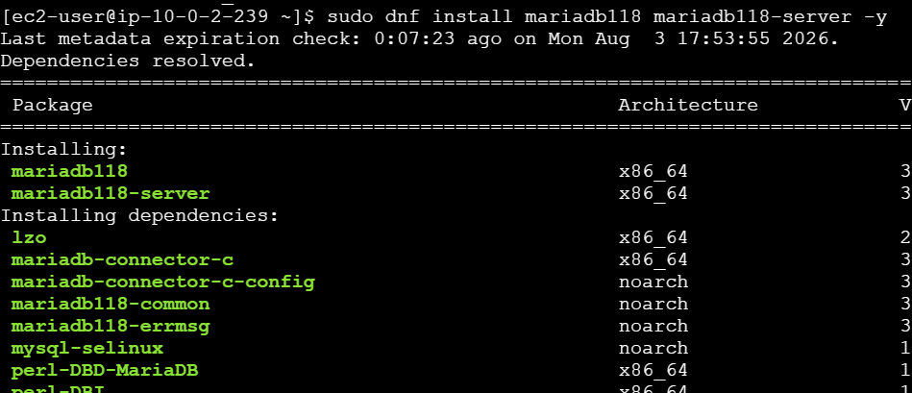

Step 2: Start the MariaDB Service
sudo systemctl start mariadb
Enable it to start automatically after reboot:
sudo systemctl enable mariadb

Step 3: Verify the Service
sudo systemctl status mariadb
You should see something similar to:
Active: active (running)
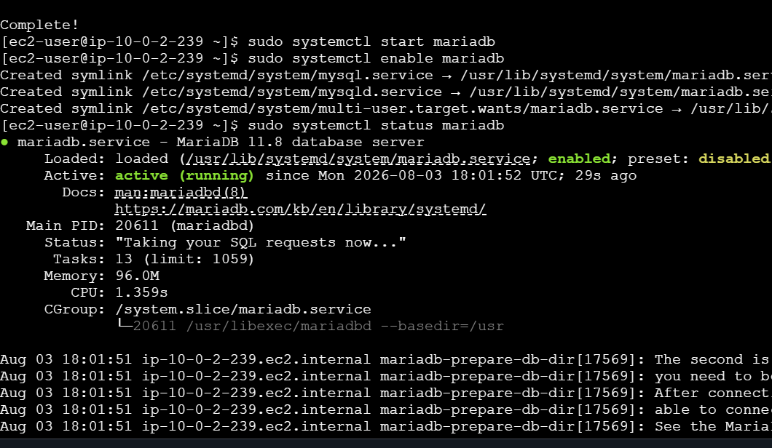

Step 4: Verify the Installation
mariadb --version
or
mysql --version
Expected output will show MariaDB 11.8.x.
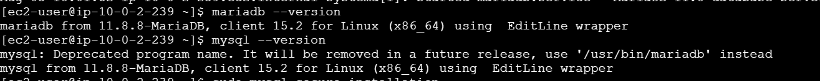

Step 5: Secure the Installation
Run:
sudo mysql_secure_installation
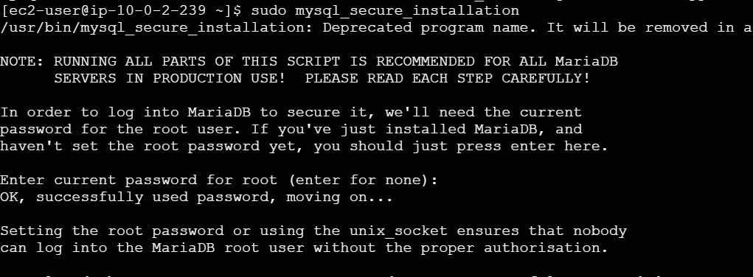
For a lab environment, you can answer:
Prompt | Answer
Switch to unix_socket authentication | Y
Change root password | N (or Y if you prefer)
Remove anonymous users | Y
Disallow root login remotely | Y
Remove test database | Y
Reload privilege tables | Y

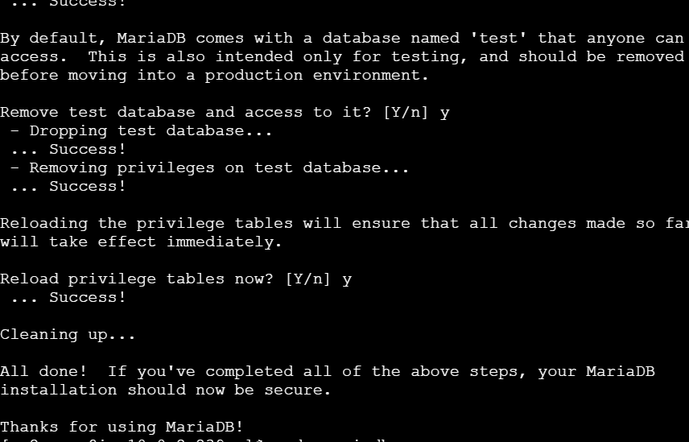
Step 6: Login to MariaDB
sudo mariadb
or
sudo mysql

Step 7: Create a Database
CREATE DATABASE mysql_lab;
Use it:
USE mysql_lab;

Step 8: Create a Table
CREATE TABLE students (
id INT AUTO_INCREMENT PRIMARY KEY,
name VARCHAR(50),
course VARCHAR(50),
marks INT
);
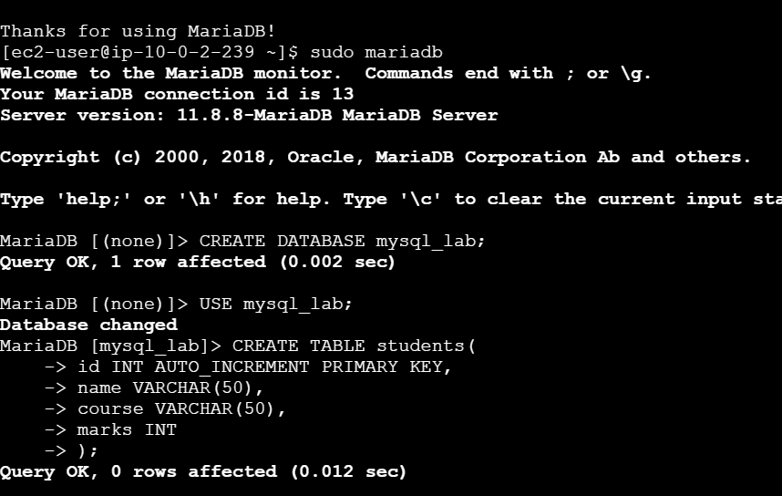

Step 9: Insert Sample Data
INSERT INTO students(name,course,marks)
VALUES
('Rahul','AWS',85),
('Anjali','Linux',90),
('Vijay','Docker',88),
('Priya','Terraform',92),
('Arjun','Kubernetes',95);

Step 10: Verify
SELECT * FROM students;
Expected output:
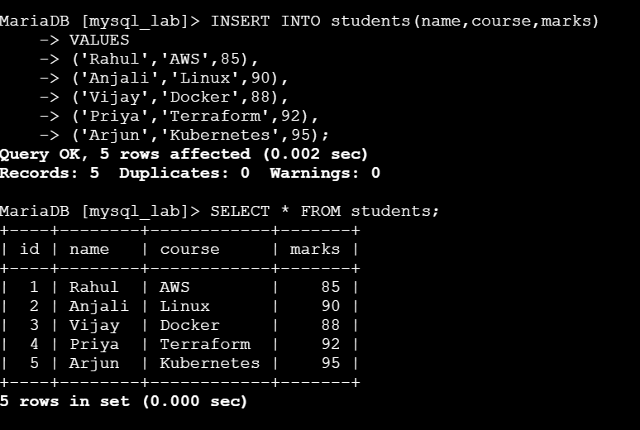

Result: MySQL is installed and ready to use on your EC2 instance.

TASK 7: Launch MySQL RDS Instance
Note: RDS provides database instances, not machine images. So you will launch a MySQL RDS DB instance.
Go to
RDS
Create Database
Choose
MySQL
Template
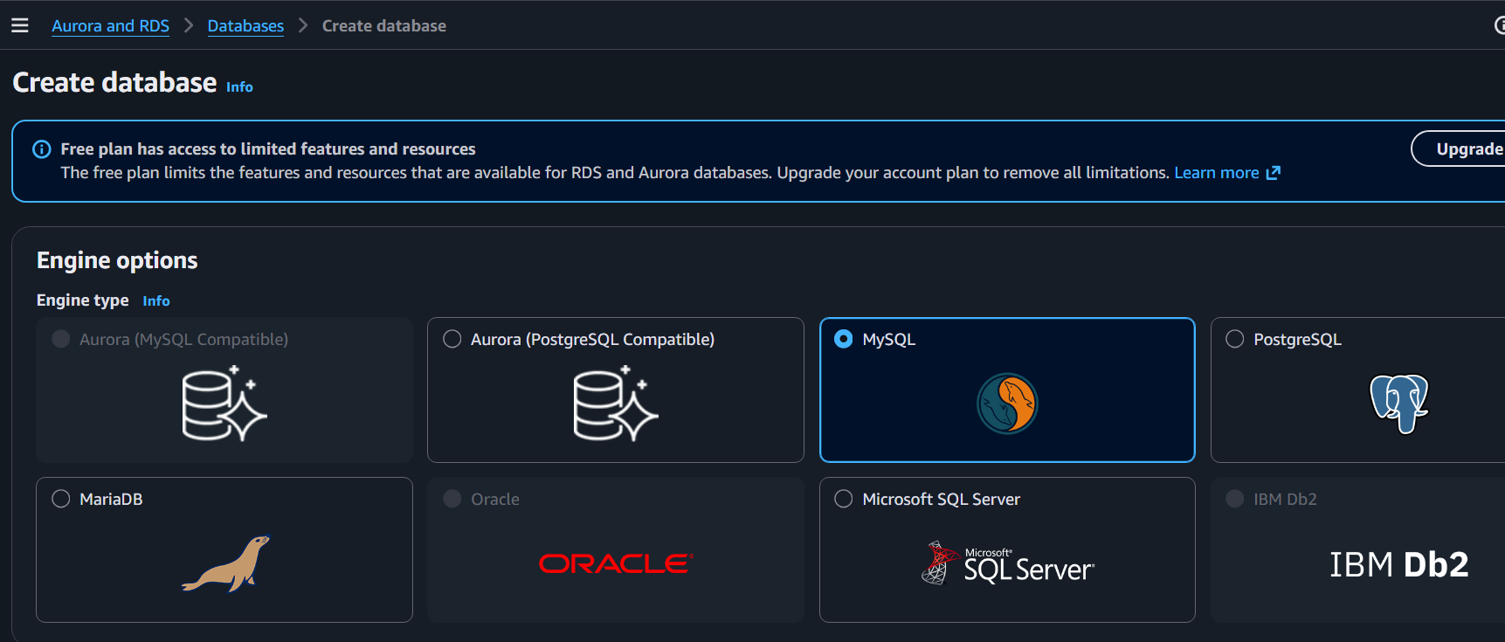
Free Tier
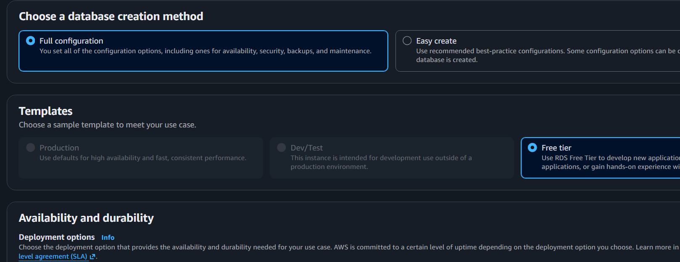
Settings
Identifier
mysql-rds
Username
Admin
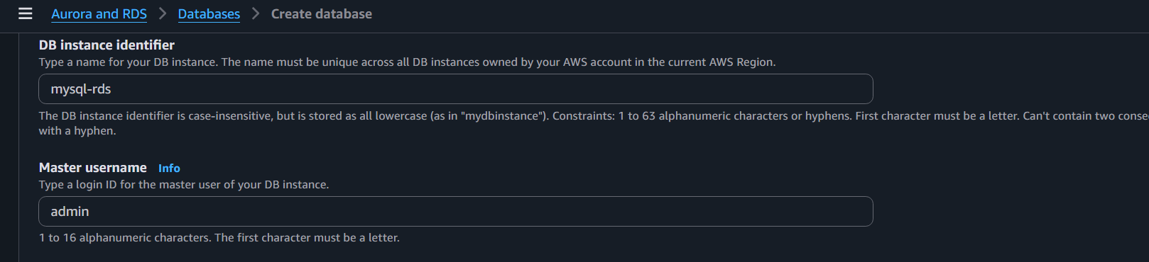
Password
Password@123
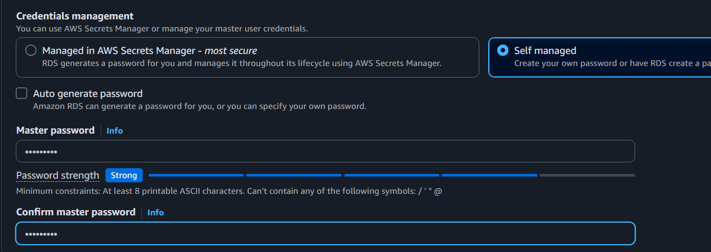
Instance
db.t3.micro
Storage
20 GB
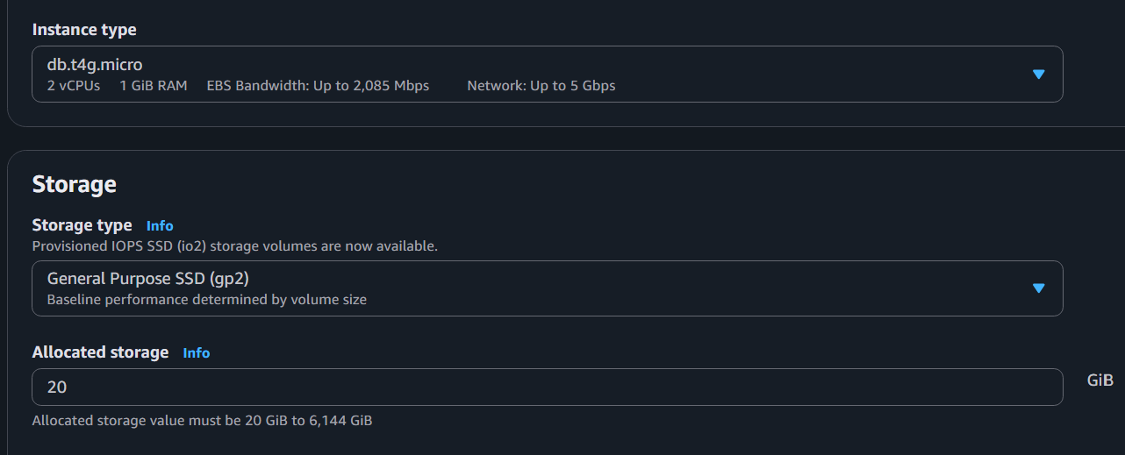
Public Access
Yes
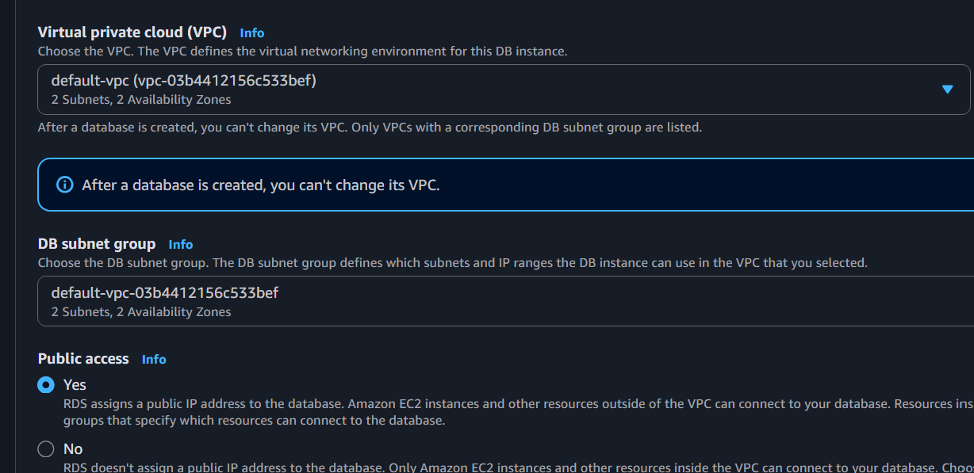
Security Group
Allow
3306
Create.
Wait until
Available
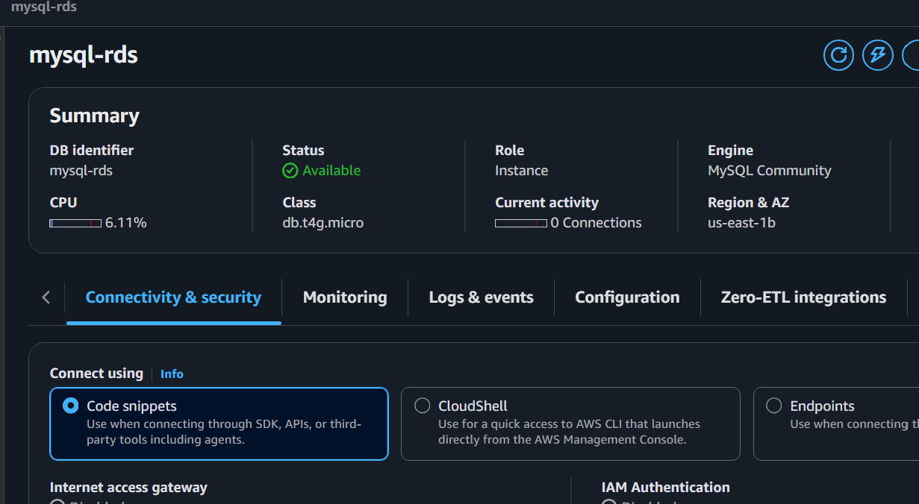

TASK 8: Configure Multi-AZ
There are two ways to do this.
Method 1: During Creation
While creating the RDS instance:
Availability & durability
Select
Multi-AZ DB instance
Continue with the remaining settings and create the instance.
Method 2: Modify an Existing DB
- Go to RDS → Databases.
- Select your MySQL DB instance.
- Click Modify.
- Under Availability & durability, enable Multi-AZ deployment.
- Choose Apply immediately (or during the maintenance window).
- Save changes.
AWS provisions a standby instance in another Availability Zone automatically. During normal operation only the primary instance is used. If the primary fails, RDS performs an automatic failover to the standby.

TASK 9: Take Backup (Snapshot) of RDS and Restore the Database
Objective
- Create a manual backup (snapshot) of your RDS database.
- Restore a new RDS instance from that snapshot.
- Verify the restored database.

Part A: Create a Manual Snapshot
Step 1: Open RDS Console
AWS Console → RDS
Click:
Databases
You should see your database, for example:
mysql-rds
or
mariadb-rds
Wait until the status is:
Available


Step 2: Select the Database
Click your DB instance.
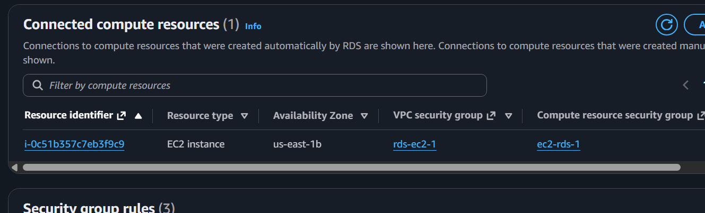

Step 3: Create Snapshot
Click
Actions
↓
Take snapshot

Step 4: Snapshot Identifier
Example:
mysql-rds-snapshot-01
or
mariadb-rds-snapshot-01
Click
Take Snapshot
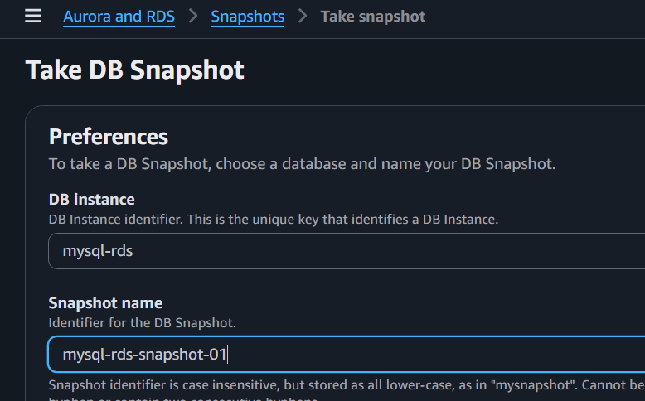

Step 5: Wait
Go to
RDS
→ Snapshots
Initially:
Creating
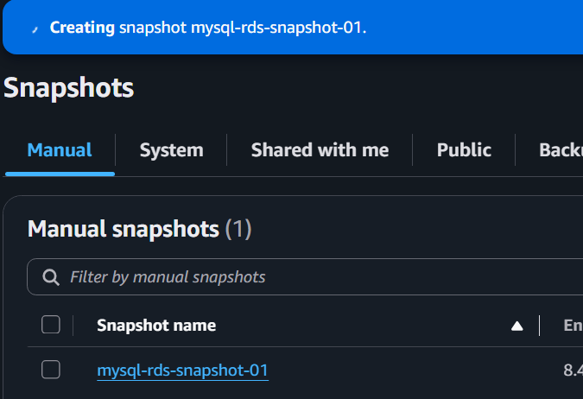
Wait until it changes to
Available
This may take 5–15 minutes depending on database size.
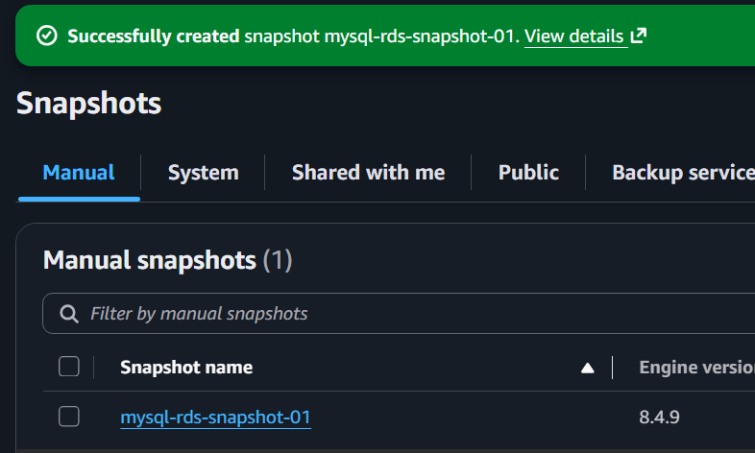

Part B: Restore Database from Snapshot

Step 6: Open Snapshots
Go to
RDS
→ Snapshots

Select:
mysql-rds-snapshot-01
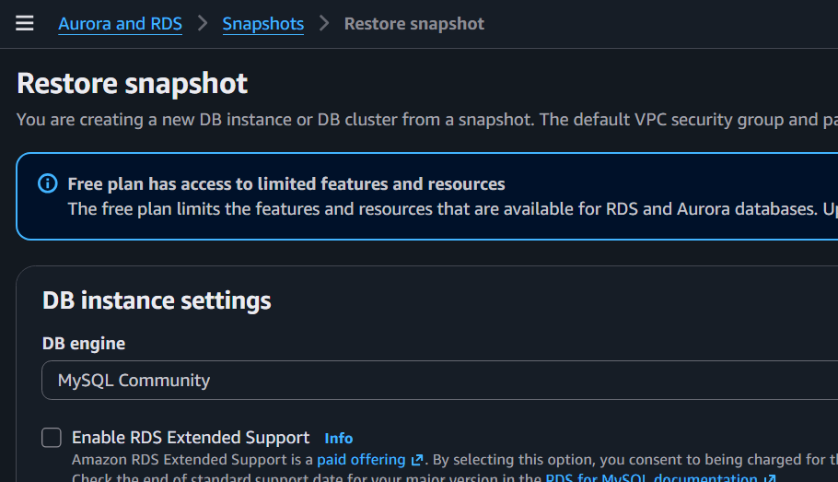

Step 7: Restore Snapshot
Click
Actions
↓
Restore snapshot

Step 8: Configure New Database
DB Instance Identifier
Example
mysql-rds-restored
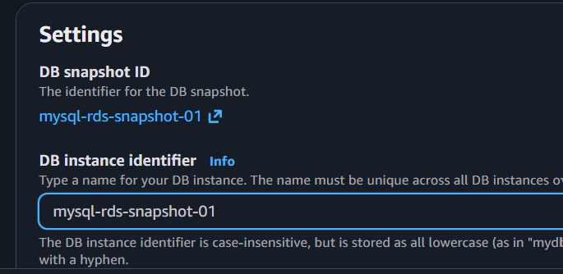

Instance Class
Choose
db.t4g.micro
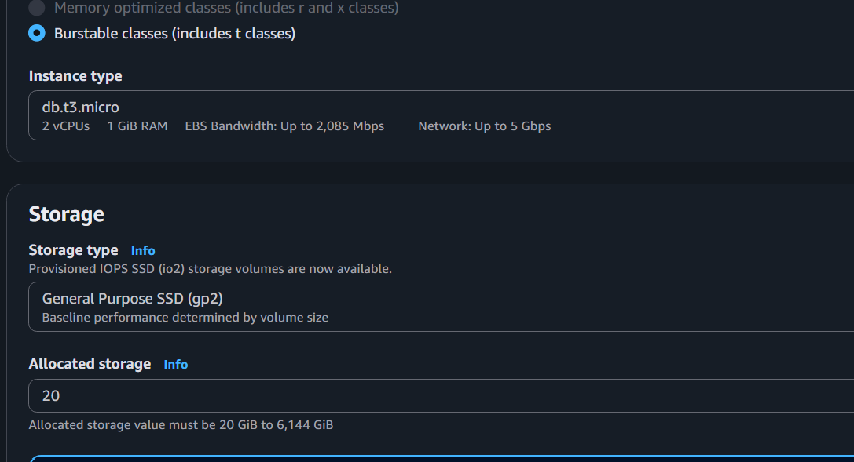

Storage
Leave default.

Step 9: Connectivity
VPC
Choose
Your VPC
Public Access
Yes
Security Group
Choose the same security group used by the original database.
Database Port
3306
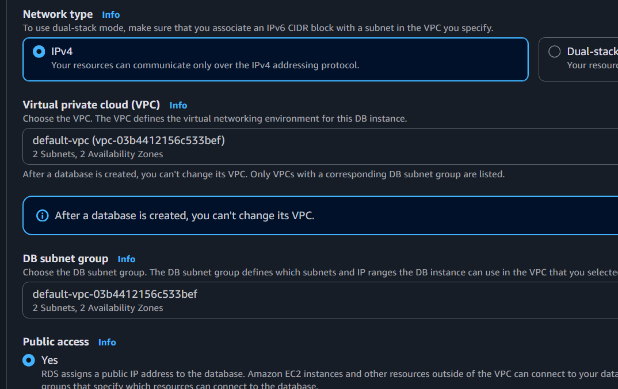

Step 10: Create Database
Click
Restore DB Instance

Wait until
Status = Available
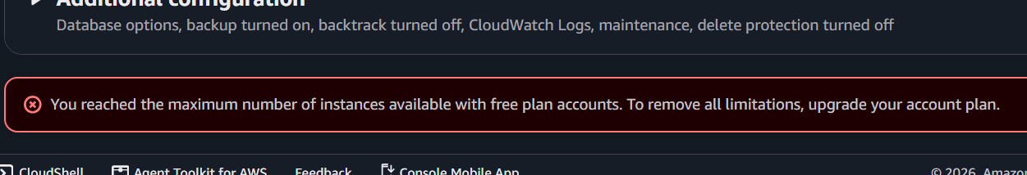

Part C: Verify Restored Database
Copy the endpoint of
mysql-rds-restored
Connect from EC2
mysql --ssl \
-h restored-endpoint \
-u admin \
-p
Check databases
SHOW DATABASES;
Use your database
USE company;
or
USE mysql_lab;
Verify data
SELECT * FROM employees;
or
SELECT * FROM students;
If data appears, the restore is successful.

TASK 10: Create Read Replica
Prerequisites:
- Source DB uses automated backups.
- The DB engine/version supports read replicas.
Steps:
- Open RDS → Databases.
- Select your primary MySQL instance.
- Click Actions → Create read replica.
- Provide a DB identifier, for example:
mysql-replica
- Keep the same Region (us-east-1) for a standard read replica.
- Choose the desired instance class (for a lab, the smallest supported option is fine if available).
- Click Create read replica.
Wait until the replica status becomes Available.
Test Replication
On the primary database:
CREATE DATABASE testdb;

USE testdb;

CREATE TABLE demo(
id INT PRIMARY KEY,
name VARCHAR(50)
);

INSERT INTO demo VALUES
(1,'AWS'),
(2,'DevOps');
Connect to the read replica:
USE testdb;

SELECT * FROM demo;
The inserted rows should appear after replication catches up

